**Appendix 1 (edited)**

**1.1 Number of Observations per species breakdown in the raw, cleaned Americas and cleaned North America datasets.**

|  |  |  |  |
| --- | --- | --- | --- |
| Species | raw | America | North America |
| *Triatoma gerstaeckeri* | 5205 | 4464 | 4464 |
| *Triatoma sanguisuga* | 2440 | 2217 | 2217 |
| *Triatoma dimidiata* | 3258 | 2905 | 1679 |
| *Triatoma protracta* | 944 | 864 | 864 |
| *Triatoma rubida* | 928 | 492 | 492 |
| *Triatoma longipennis* | 563 | 482 | 482 |
| *Meccus pallidipennis* | 564 | 465 | 465 |
| *Triatoma barberi* | 732 | 380 | 380 |
| *Triatoma mexicana* | 847 | 358 | 358 |
| *Paratriatoma lecticularia* | 323 | 275 | 275 |
| *Triatoma indictiva* | 222 | 204 | 204 |
| *Triatoma mazzottii* | 165 | 158 | 158 |
| *Triatoma recurva* | 127 | 112 | 112 |
| *Dipetalogaster maxima* | 146 | 96 | 96 |
| *Triatoma phyllosoma* | 75 | 71 | 71 |
| *Paratriatoma hirsuta* | 67 | 64 | 64 |
| *Triatoma picturata* | 47 | 37 | 37 |
| *Triatoma neotomae* | 43 | 32 | 32 |
| *Triatoma brailovskyi* | 22 | 20 | 20 |
| *Triatoma bolivari* | 21 | 18 | 18 |
| *Triatoma huehuetenanguensis* | 53 | 52 | 16 |
| *Eratyrus cuspidatus* | 128 | 124 | 11 |
| *Triatoma hegneri* | 11 | 11 | 11 |
| *Triatoma sinaloensis* | 10 | 9 | 9 |
| *Triatoma nitida* | 79 | 74 | 8 |
| *Triatoma yelapensis* | 7 | 7 | 7 |
| *Triatoma bassolsae* | 7 | 6 | 6 |
| *Triatoma incrassata* | 5 | 5 | 5 |
| *Panstrongylus rufotuberculatus* | 39 | 37 | 4 |
| *Triatoma infestans* | 65 | 4 | 4 |
| *Belminus costaricensis* | 2 | 2 | 2 |
| *Rhodnius prolixus* | 1233 | 1050 | 2 |
| *Triatoma gomeznunezi* | 2 | 2 | 2 |
| *Panstrongylus geniculatus* | 102 | 100 | 1 |
| *Triatoma peninsularis* | 9 | 1 | 1 |
| *Alberprosenia goyovargasi* | 2 | 2 |  |
| *Alberprosenia malheiroi* | 3 | 1 |  |
| *Belminus corredori* | 1 | 1 |  |
| *Belminus ferroae* | 4 | 2 |  |
| *Belminus herreri* | 28 | 27 |  |
| *Belminus laportei* | 4 | 1 |  |
| *Belminus peruvianus* | 6 | 6 |  |
| *Belminus pittieri* | 1 | 1 |  |
| *Belminus rugulosus* | 3 | 3 |  |
| *Bolbodera scabrosa* | 3 | 3 |  |
| *Cavernicola lenti* | 30 | 22 |  |
| *Cavernicola pilosa* | 42 | 29 |  |
| *Eratyrus mucronatus* | 106 | 71 |  |
| *Hermanlentia matsunoi* | 4 | 4 |  |
| *Mepraia gajardoi* | 28 | 8 |  |
| *Mepraia spinolai* | 176 | 23 |  |
| *Microtriatoma borbai* | 6 | 3 |  |
| *Microtriatoma trinidadensis* | 13 | 8 |  |
| *Nesotriatoma confusa* | 13 | 13 |  |
| *Nesotriatoma flavida* | 8 | 4 |  |
| *Nesotriatoma obscura* | 3 | 3 |  |
| *Panstrongylus chinai* | 80 | 79 |  |
| *Panstrongylus diasi* | 32 | 24 |  |
| *Panstrongylus hispaniolae* | 1 | 1 |  |
| *Panstrongylus howardi* | 9 | 9 |  |
| *Panstrongylus humeralis* | 10 | 10 |  |
| *Panstrongylus lignarius* | 64 | 35 |  |
| *Panstrongylus lutzi* | 655 | 491 |  |
| *Panstrongylus megistus* | 8 |  |  |
| *Panstrongylus mitarakaensis* | 1 |  |  |
| *Panstrongylus tupynambai* | 18 | 15 |  |
| *Parabelminus carioca* | 1 | 1 |  |
| *Parabelminus yurupucu* | 2 | 1 |  |
| *Psammolestes arthuri* | 21 | 21 |  |
| *Psammolestes tertius* | 113 | 73 |  |
| *Rhodnius amazonicus* | 8 | 1 |  |
| *Rhodnius barretti* | 3 | 3 |  |
| *Rhodnius brethesi* | 19 | 17 |  |
| *Rhodnius colombiensis* | 24 | 24 |  |
| *Rhodnius dalessandroi* | 2 | 2 |  |
| *Rhodnius domesticus* | 19 | 19 |  |
| *Rhodnius ecuadoriensis* | 108 | 105 |  |
| *Rhodnius marabaensis* | 1 | 1 |  |
| *Rhodnius micki* | 2 | 2 |  |
| *Rhodnius milesi* | 3 | 2 |  |
| *Rhodnius montenegrensis* | 8 | 8 |  |
| *Rhodnius nasutus* | 68 | 39 |  |
| *Rhodnius neglectus* | 153 | 111 |  |
| *Rhodnius neivai* | 7 | 6 |  |
| *Rhodnius pallescens* | 181 | 178 |  |
| *Rhodnius paraensis* | 9 | 4 |  |
| *Rhodnius pictipes* | 182 | 155 |  |
| *Rhodnius robustus* | 122 | 96 |  |
| *Rhodnius stali* | 12 | 8 |  |
| *Triatoma arthurneivai* | 9 | 6 |  |
| *Triatoma bahiensis* | 3 | 3 |  |
| *Triatoma baratai* | 16 | 9 |  |
| *Triatoma boliviana* | 2 | 2 |  |
| *Triatoma brasiliensis* | 1120 | 1040 |  |
| *Triatoma carcavalloi* | 16 | 11 |  |
| *Triatoma carrioni* | 38 | 38 |  |
| *Triatoma circummaculata* | 40 | 26 |  |
| *Triatoma costalimai* | 46 | 11 |  |
| *Triatoma deaneorum* | 3 | 3 |  |
| *Triatoma dispar* | 278 | 277 |  |
| *Triatoma dominicana* | 1 | 1 |  |
| *Triatoma guasayana* | 2 |  |  |
| *Triatoma guazu* | 9 | 7 |  |
| *Triatoma jatai* | 4 | 3 |  |
| *Triatoma juazeirensis* | 22 | 19 |  |
| *Triatoma jurbergi* | 10 | 10 |  |
| *Triatoma klugi* | 6 | 5 |  |
| *Triatoma maculata* | 174 | 166 |  |
| *Triatoma matogrossensis* | 16 | 7 |  |
| *Triatoma melanica* | 24 | 22 |  |
| *Triatoma melanocephala* | 136 | 83 |  |
| *Triatoma mopan* | 9 | 9 |  |
| *Triatoma nigromaculata* | 15 | 13 |  |
| *Triatoma oliveirai* | 8 | 4 |  |
| *Triatoma petrochiae* | 32 | 13 |  |
| *Triatoma pintodiasi* | 1 | 1 |  |
| *Triatoma pseudomaculata* | 1427 | 1222 |  |
| *Triatoma rubrovaria* | 5 |  |  |
| *Triatoma ryckmani* | 8 | 6 |  |
| *Triatoma sherlocki* | 21 | 21 |  |
| *Triatoma sordida* | 4 |  |  |
| *Triatoma tibiamaculata* | 88 | 80 |  |
| *Triatoma vandae* | 10 | 9 |  |
| *Triatoma venosa* | 62 | 62 |  |
| *Triatoma vitticeps* | 117 | 83 |  |
| *Triatoma williami* | 32 | 24 |  |
| *Triatoma wygodzinskyi* | 10 | 7 |  |

**1.2 Triatomine Habitat Suitability Distribution Maps**

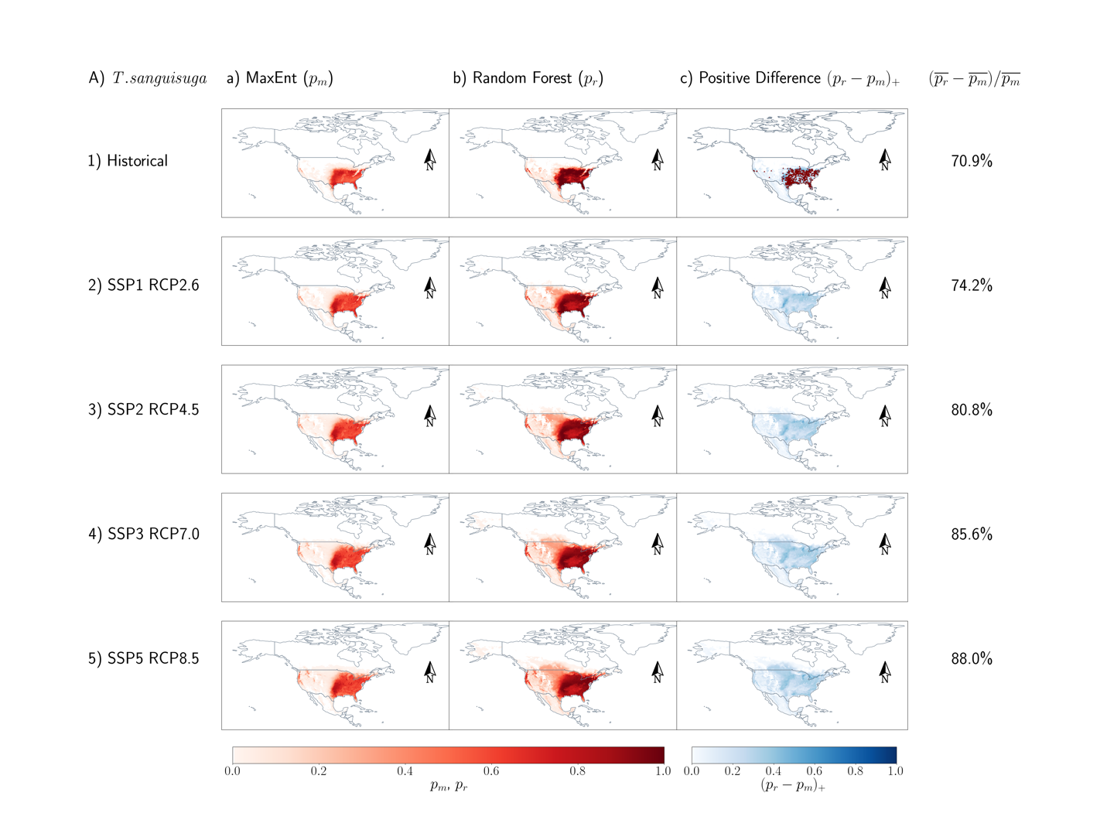

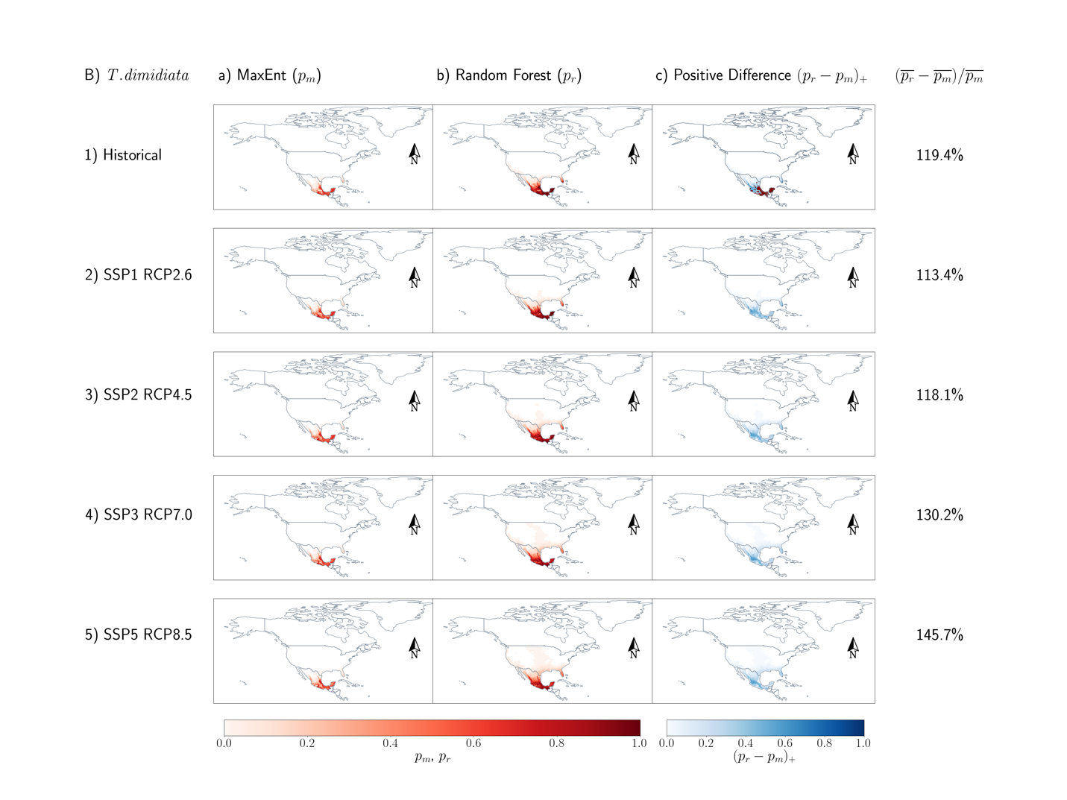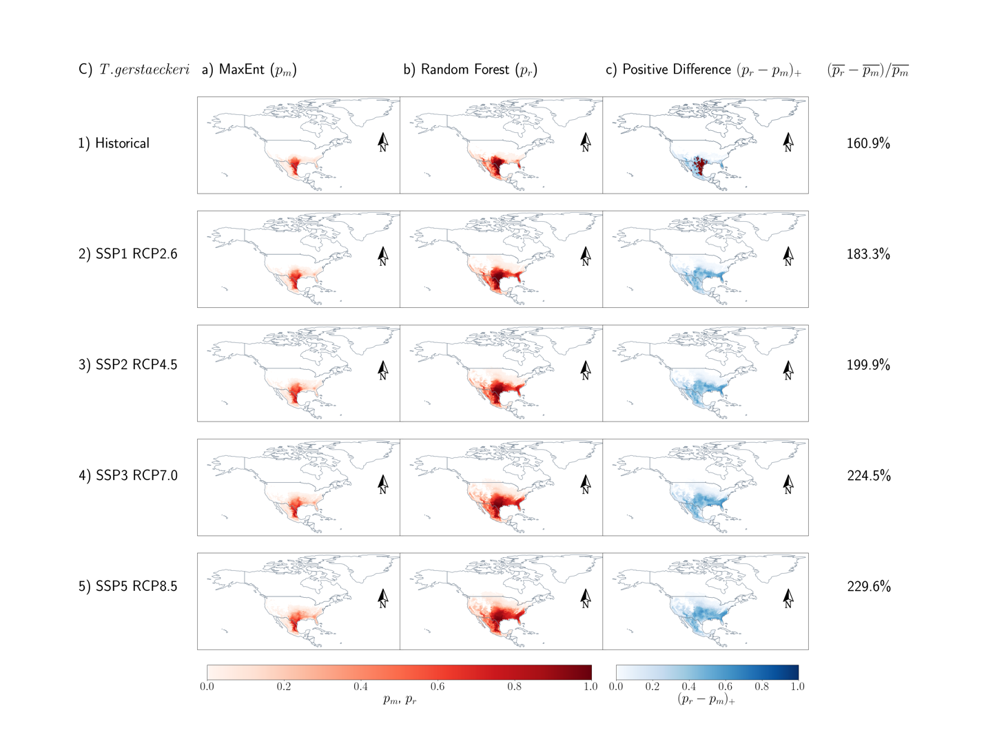 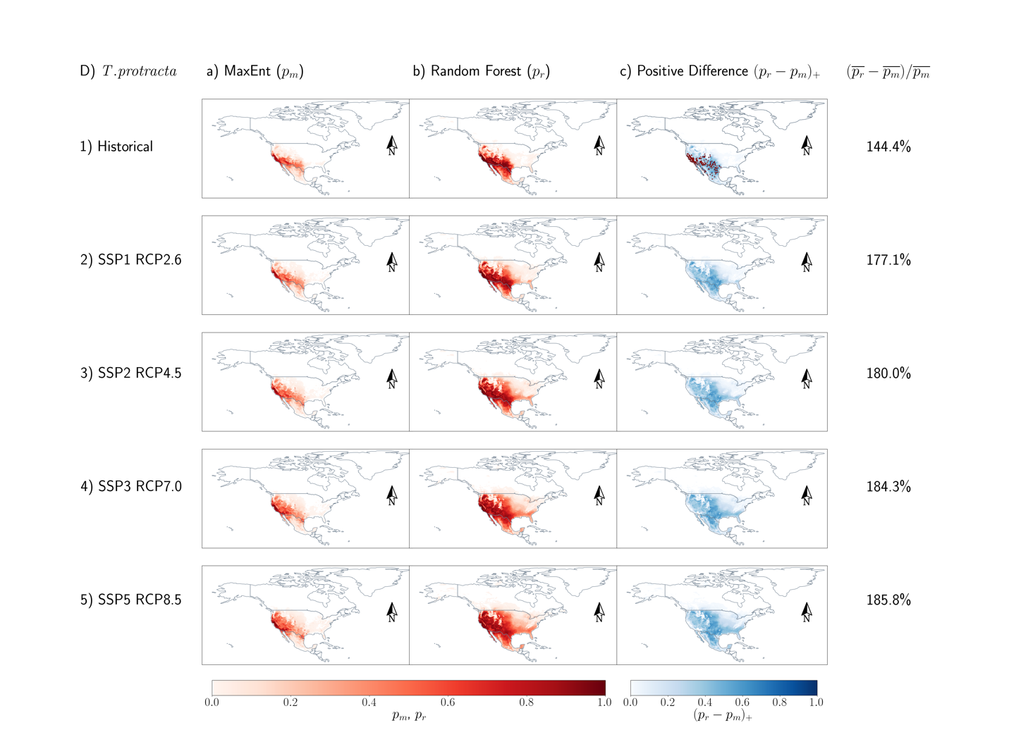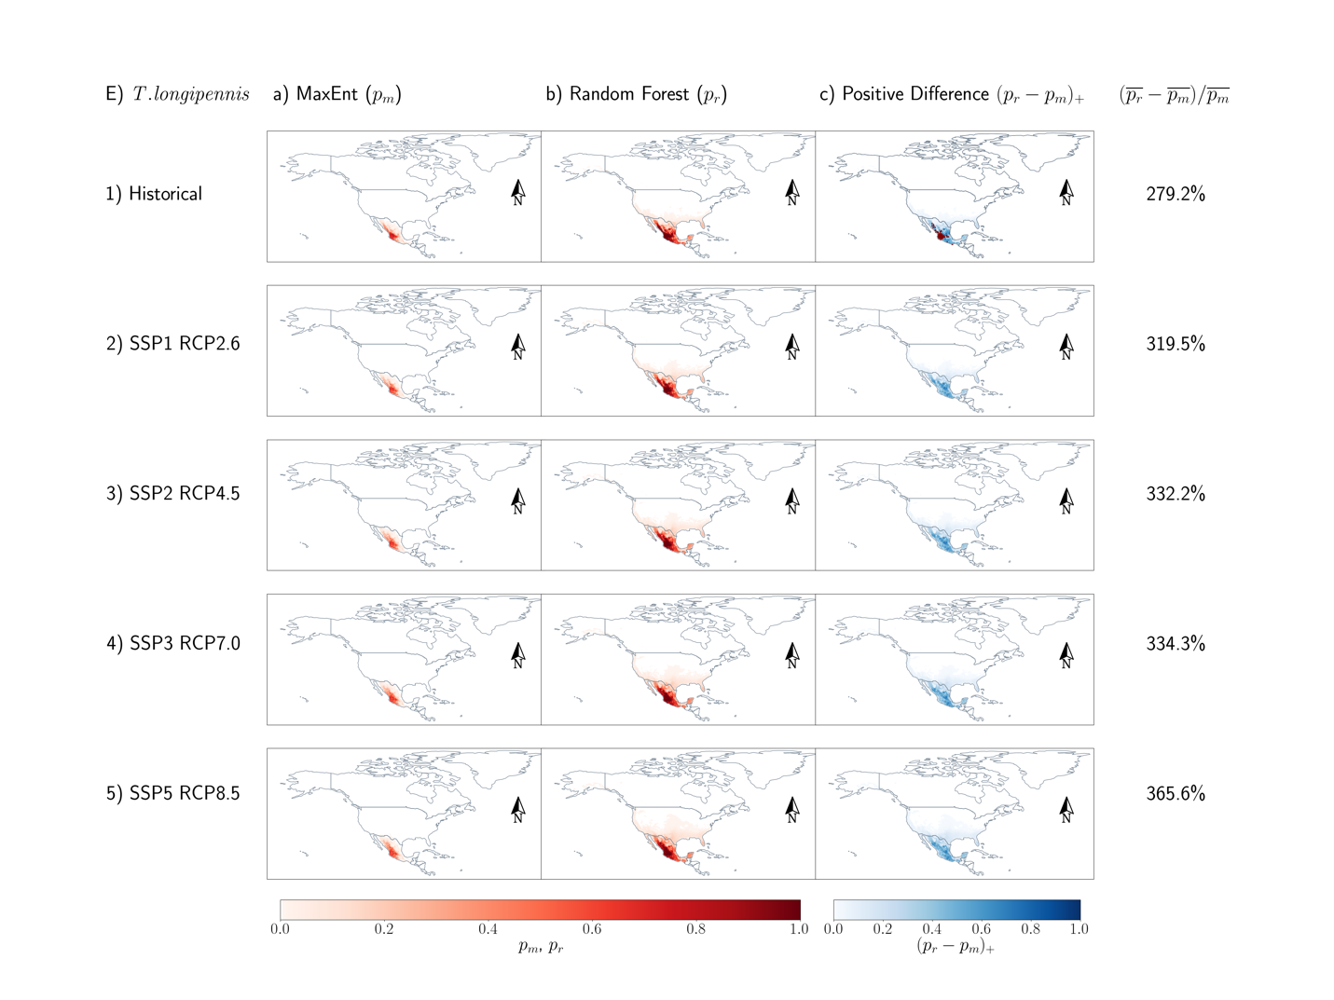 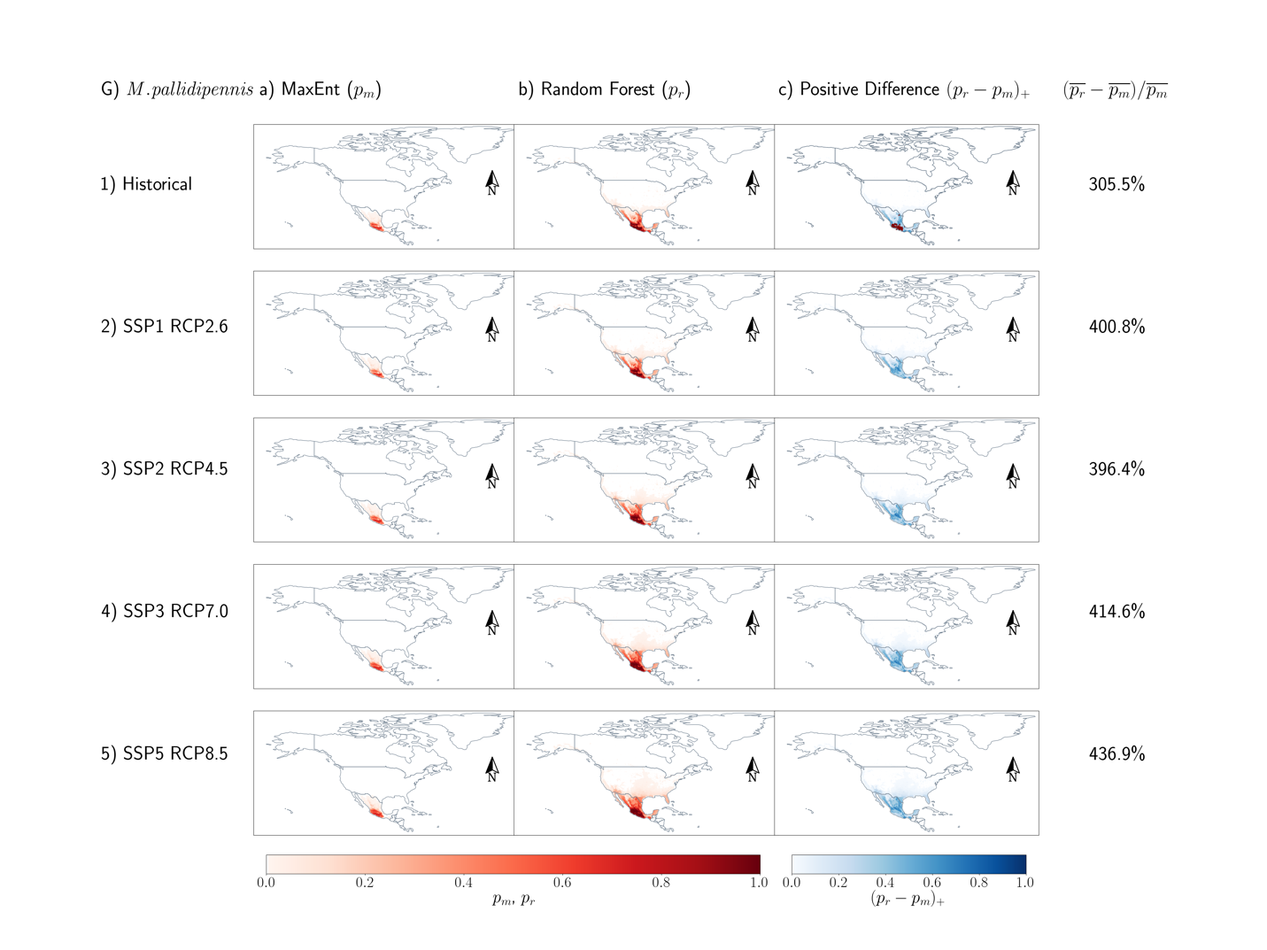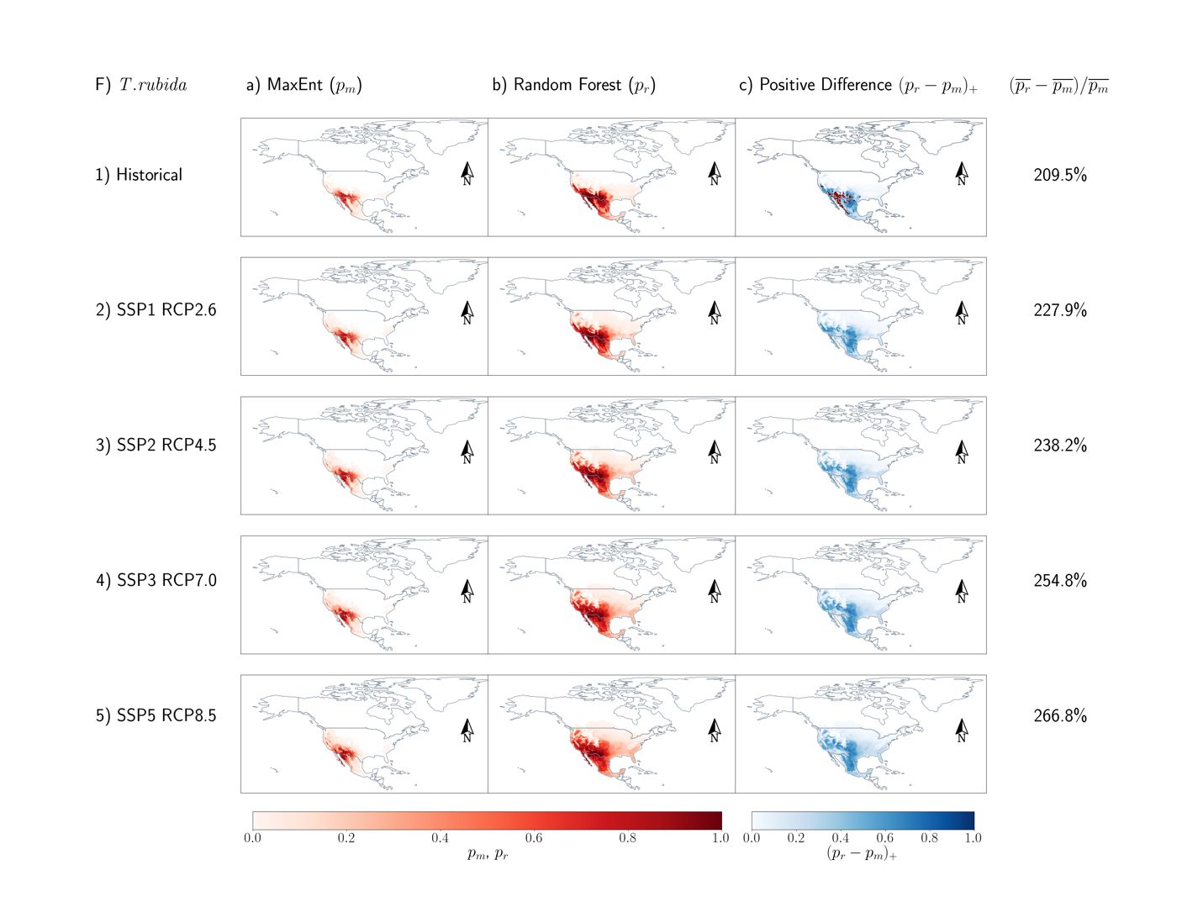 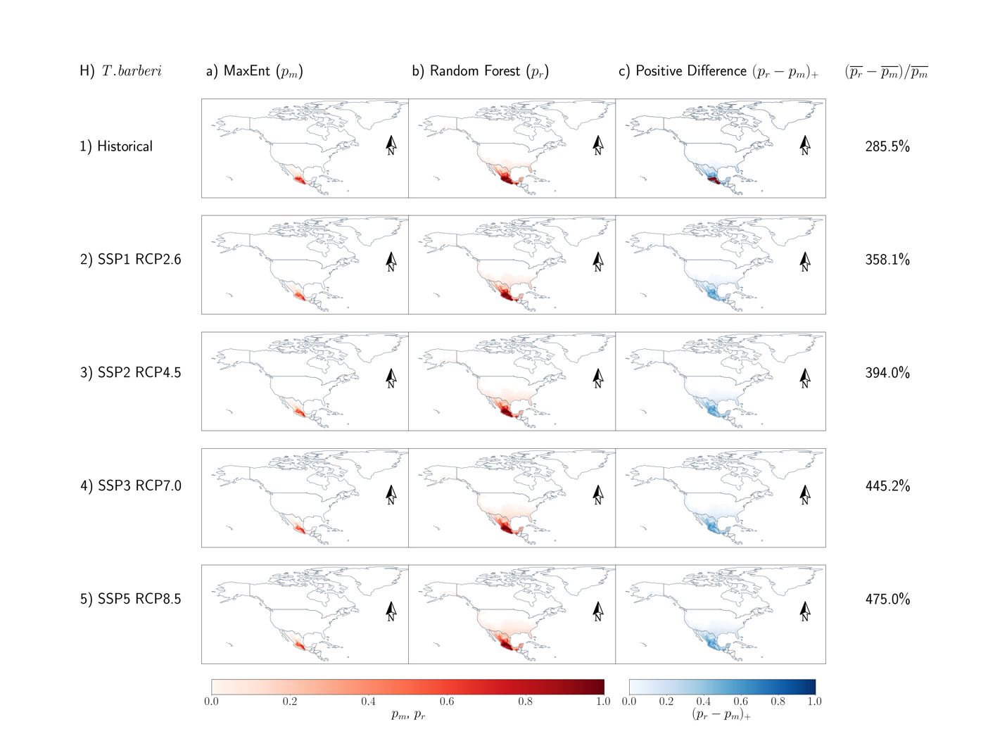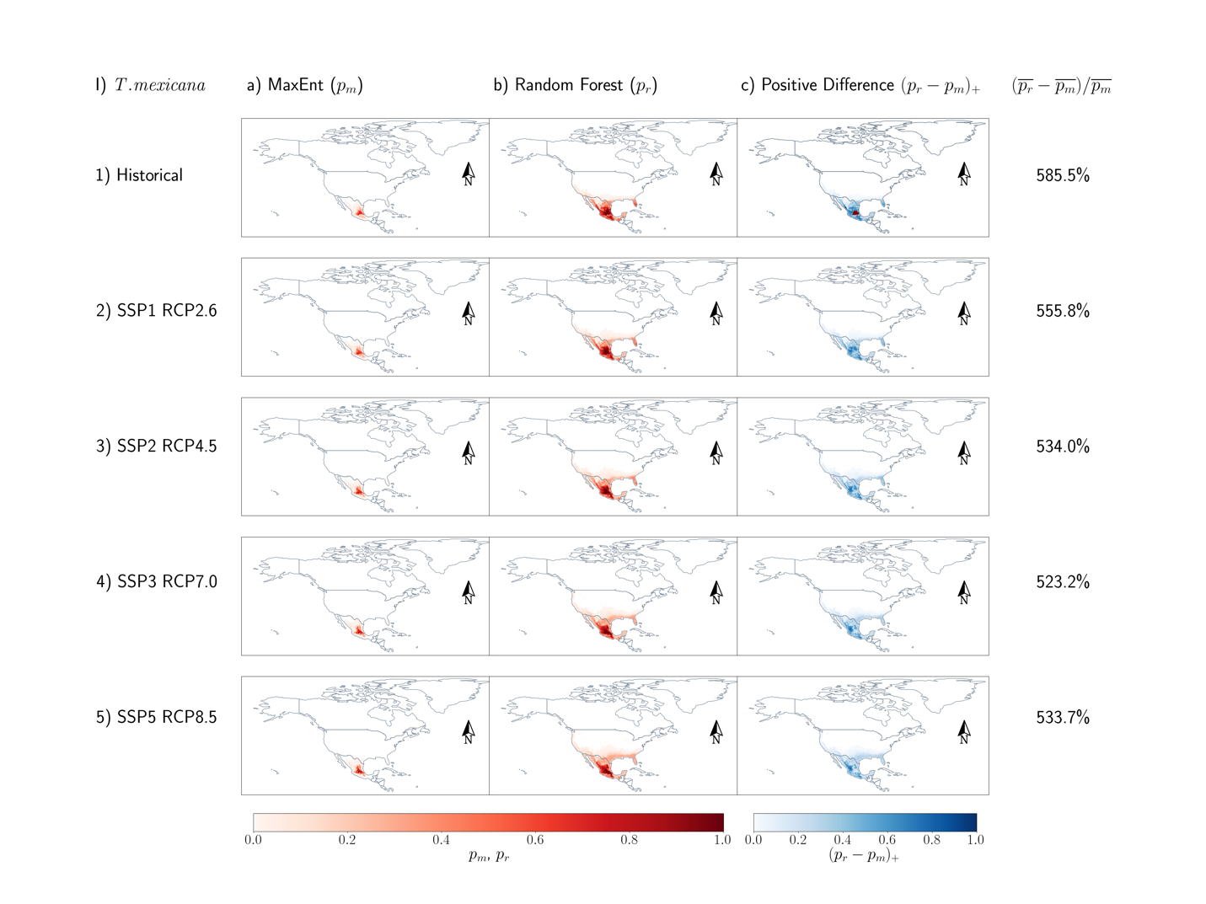 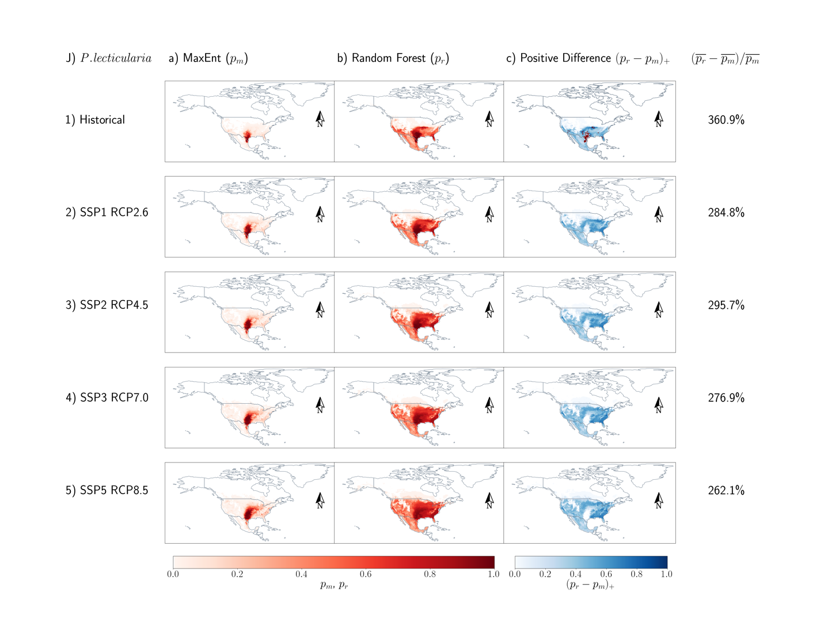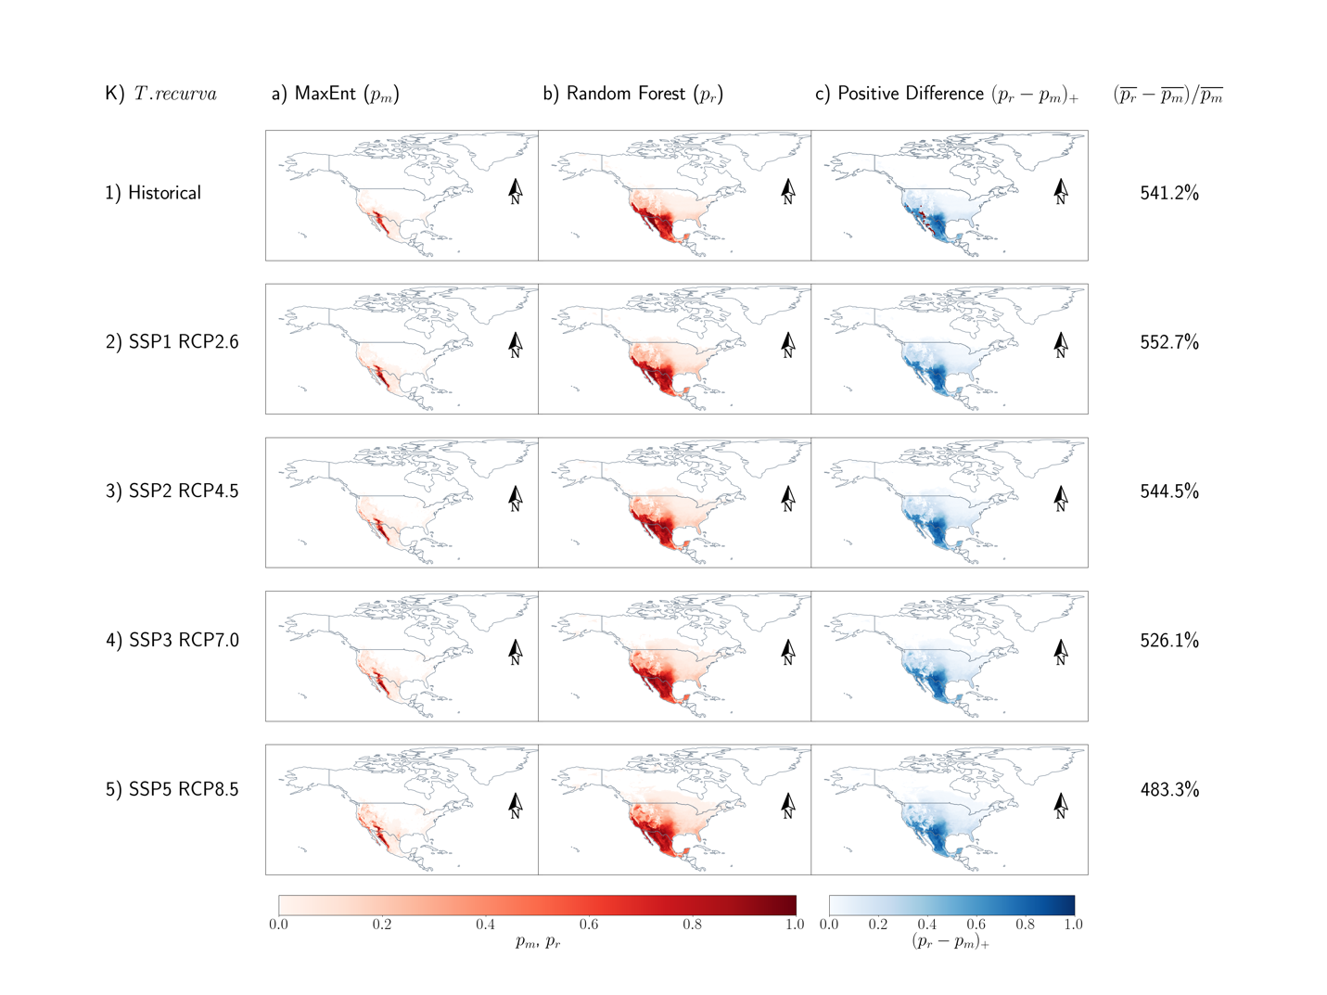 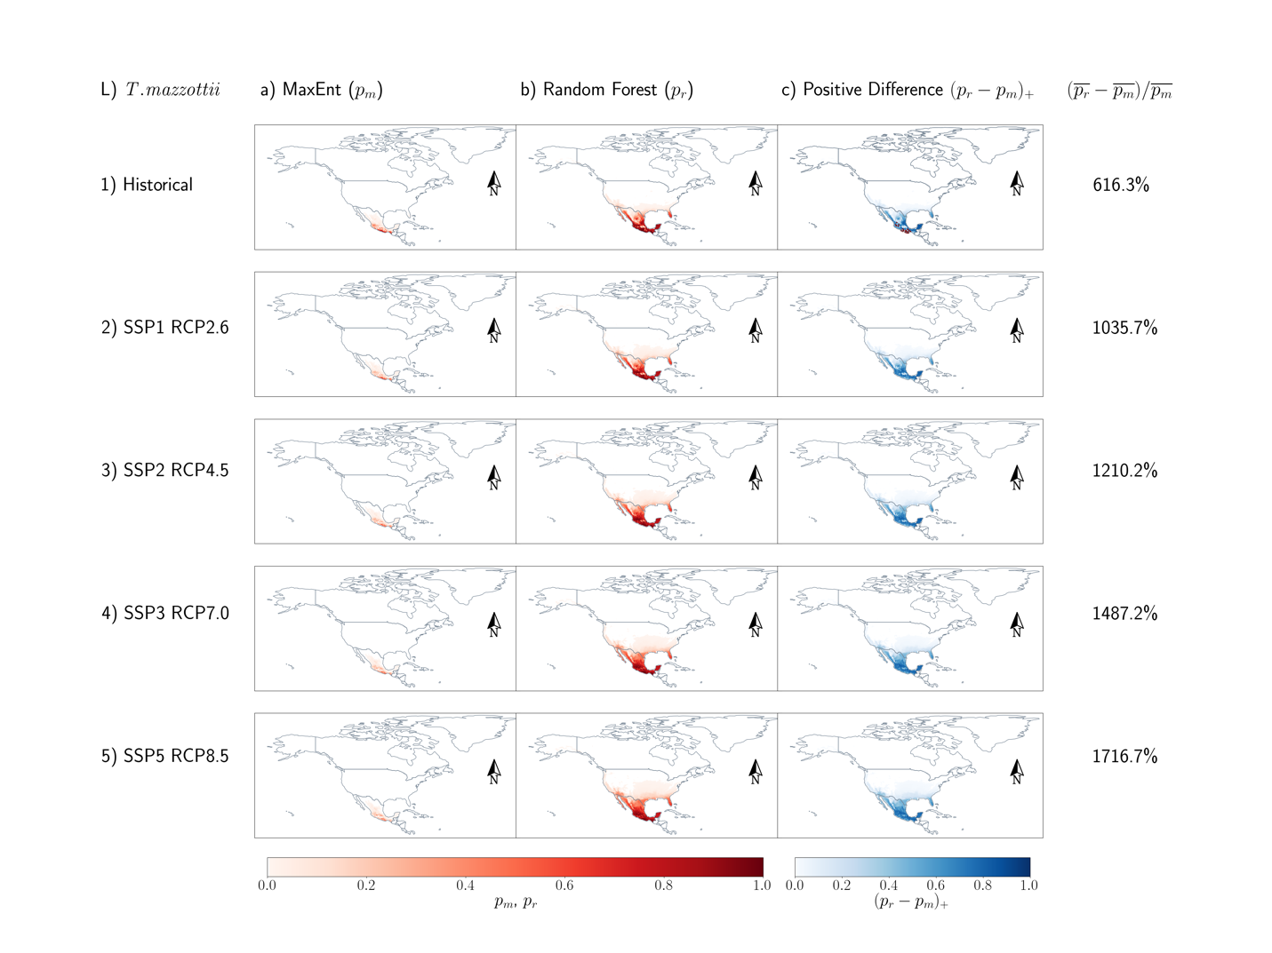 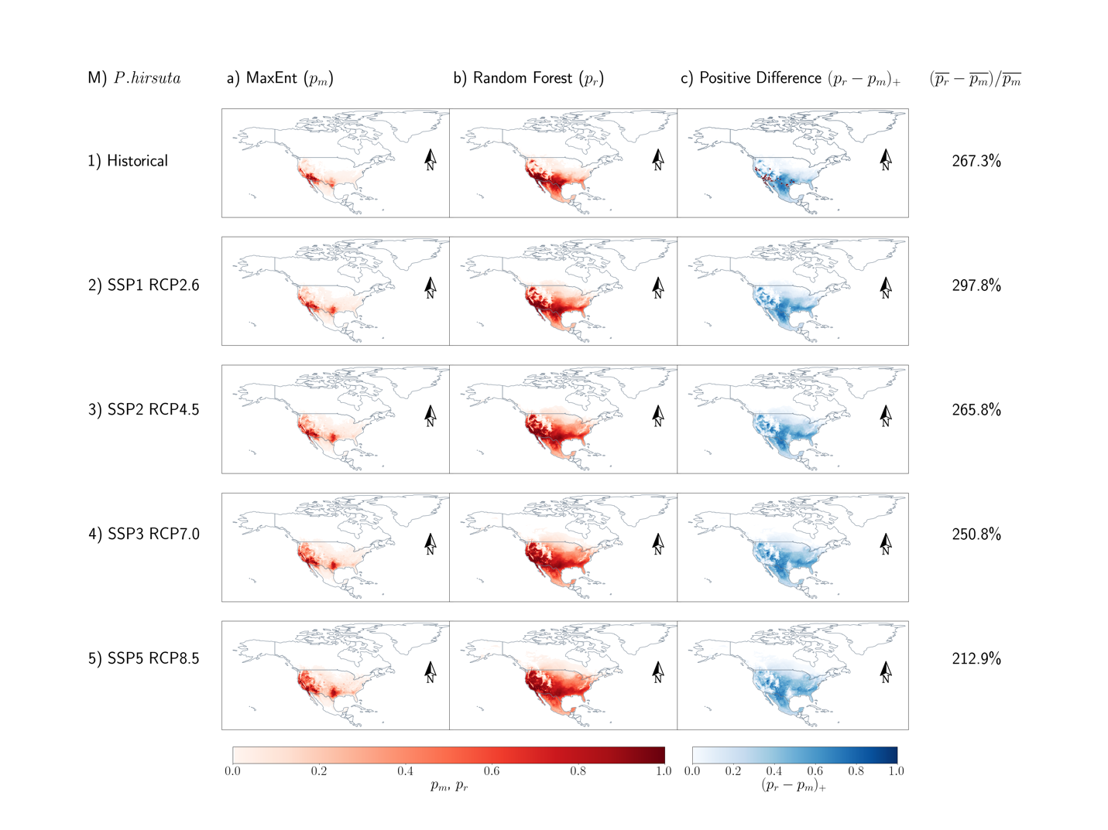

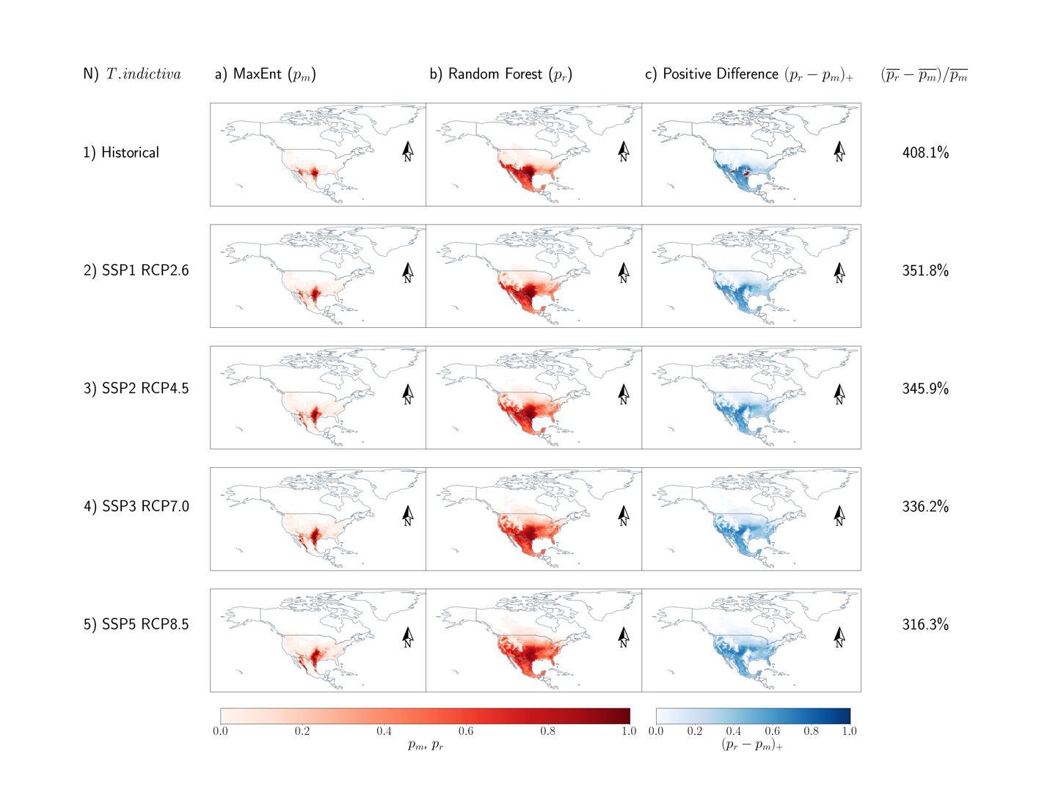

**1.3 Triatomine Variable Importance Plots**

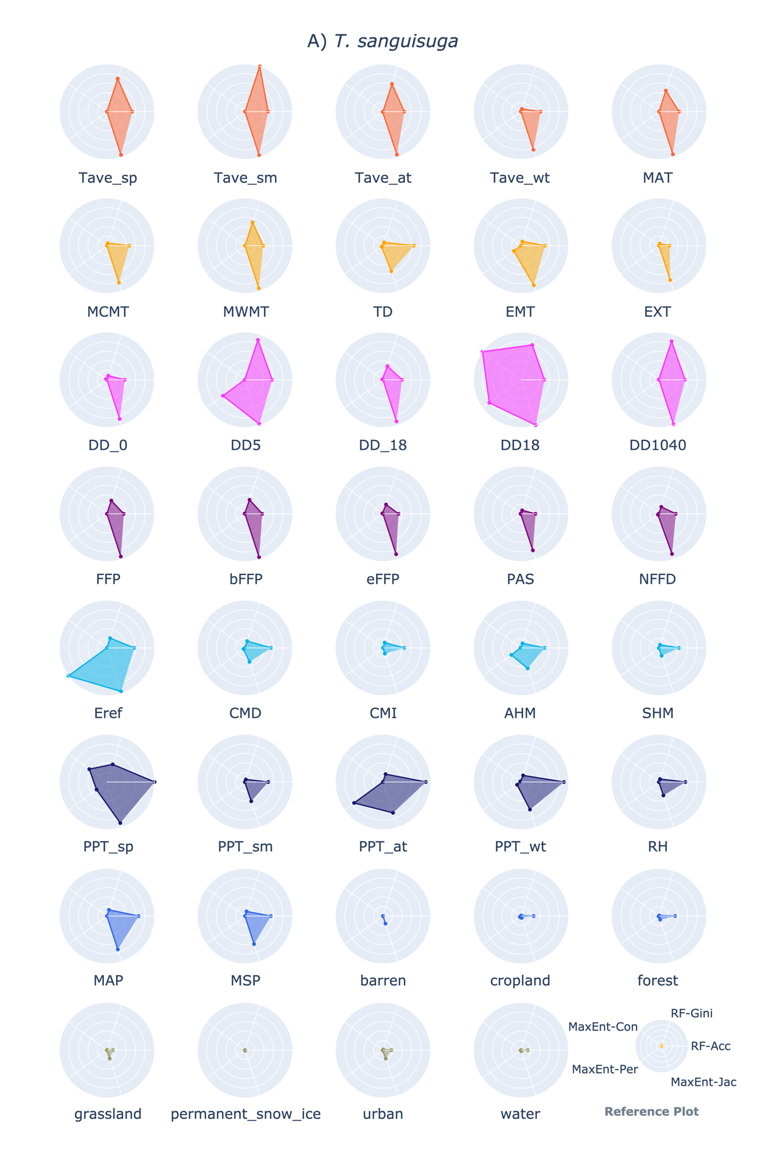

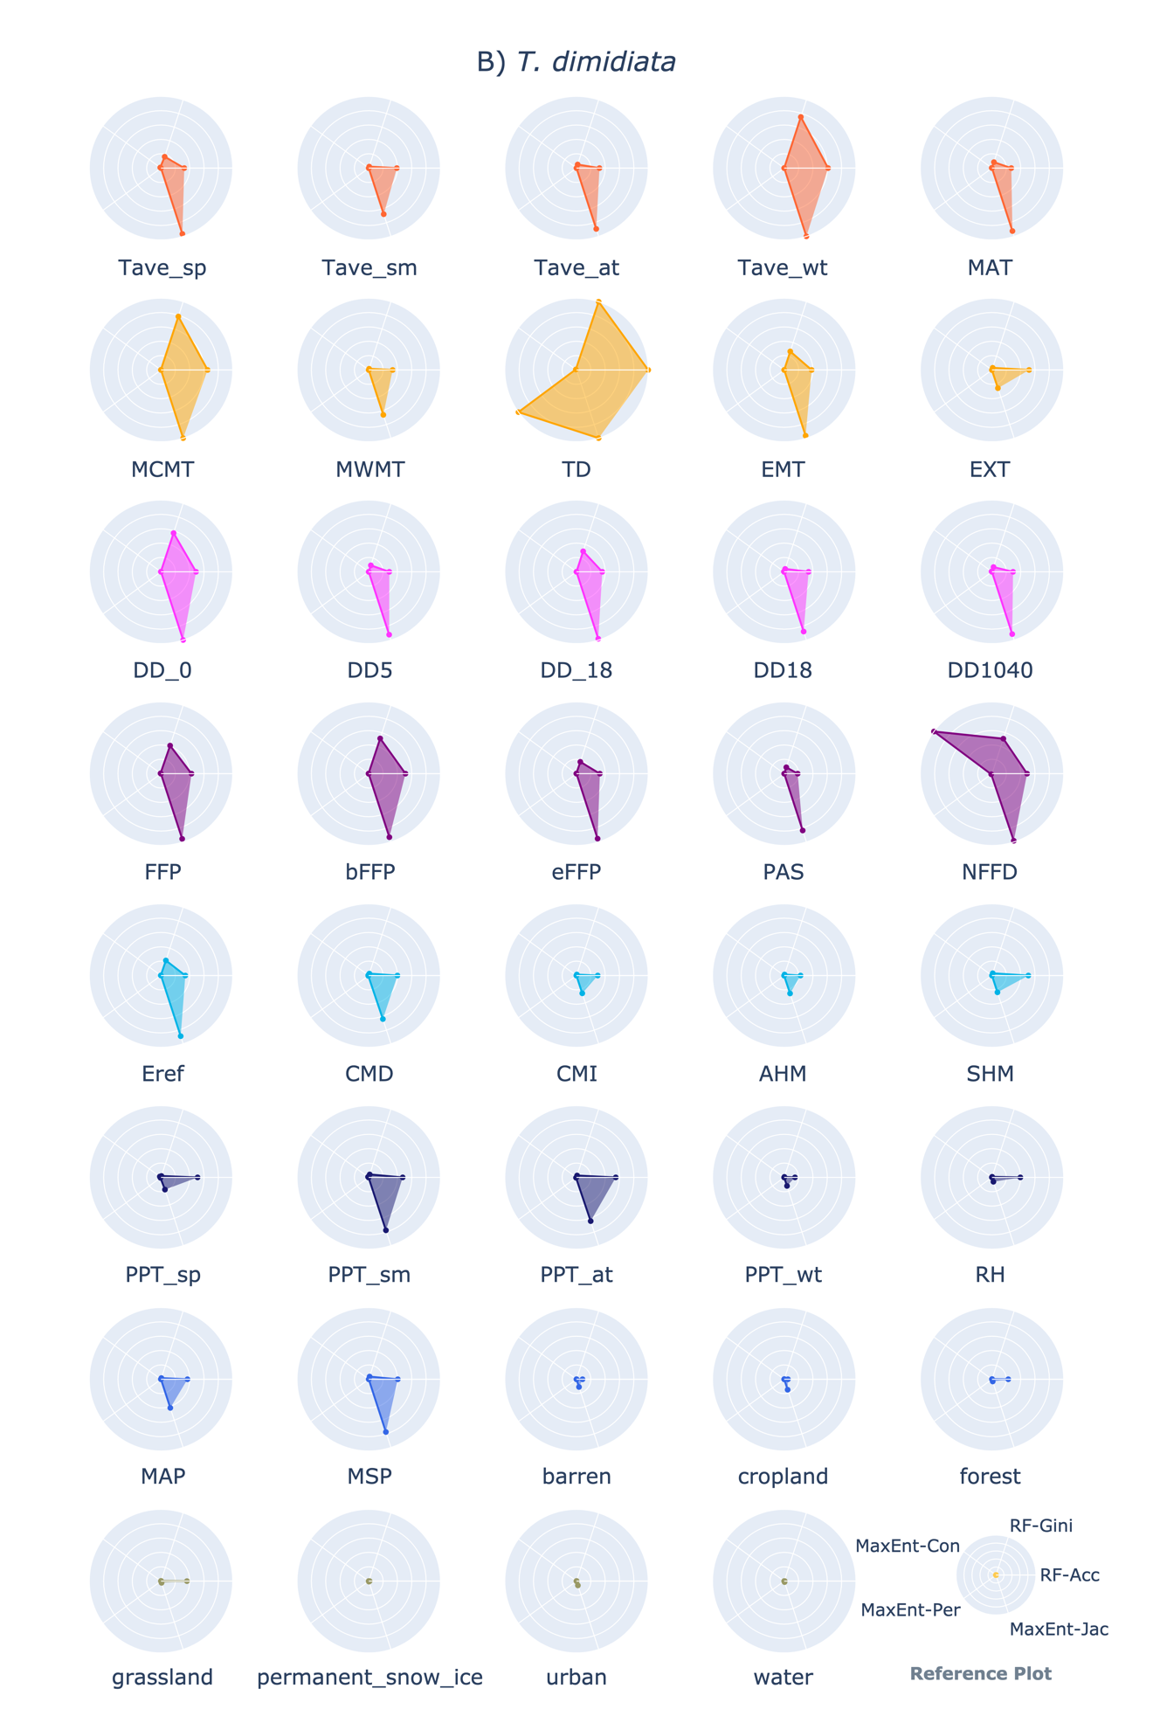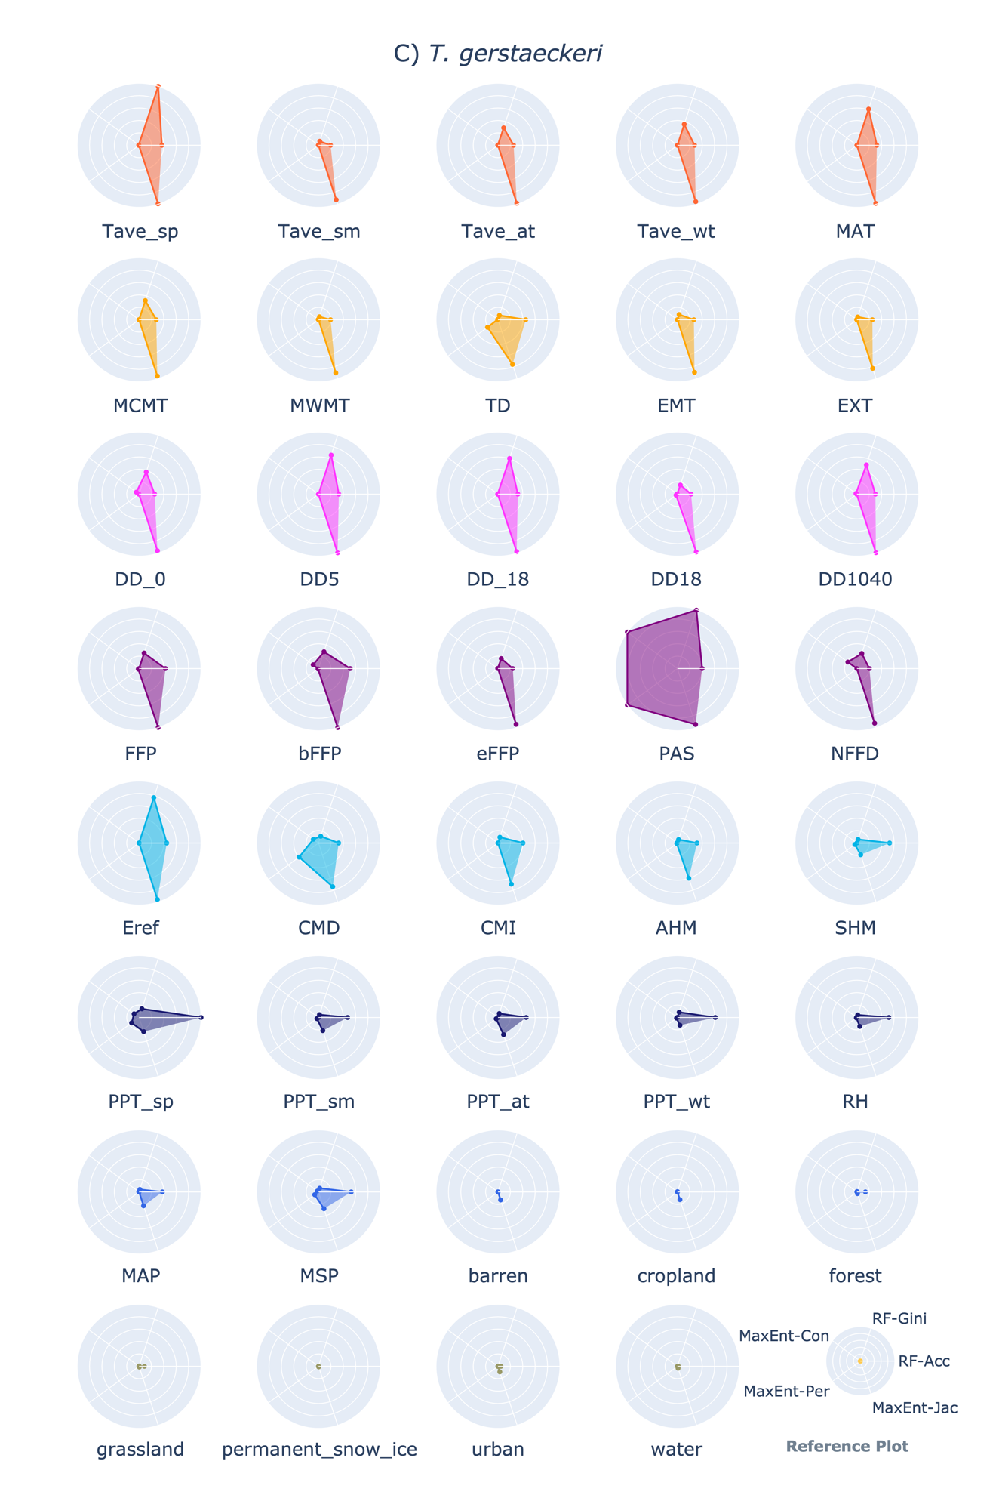

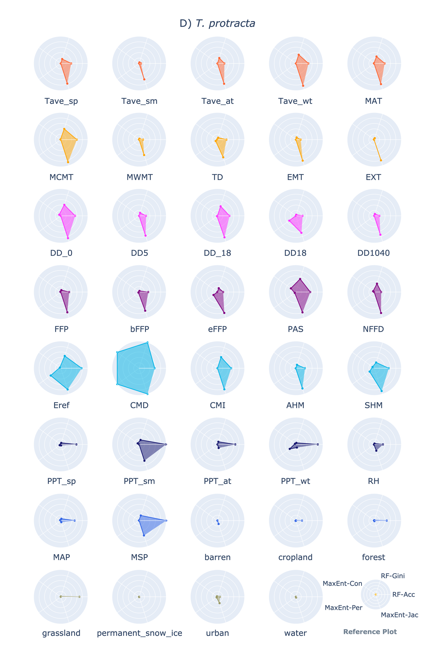 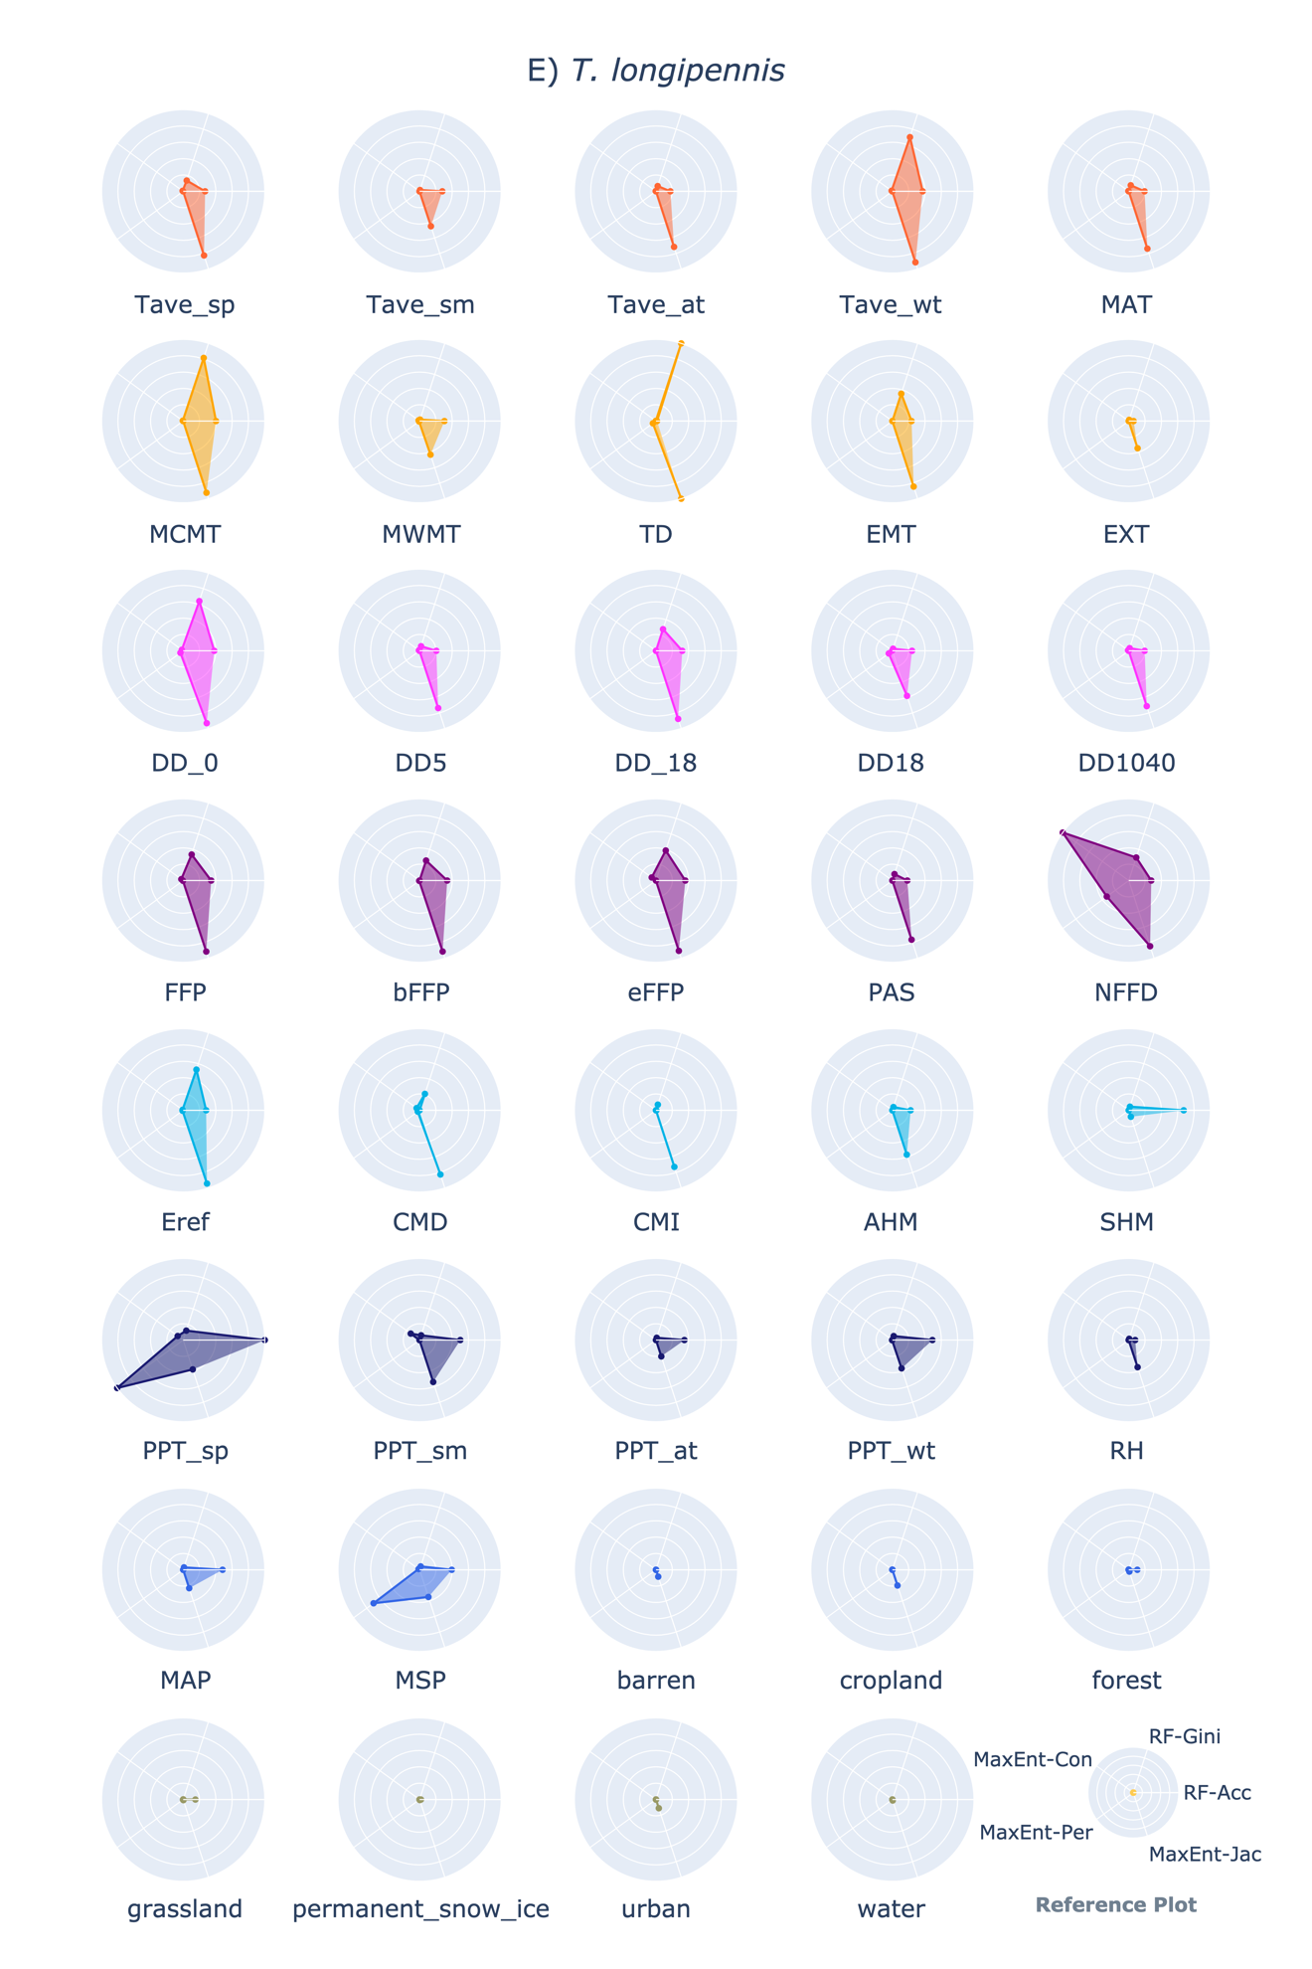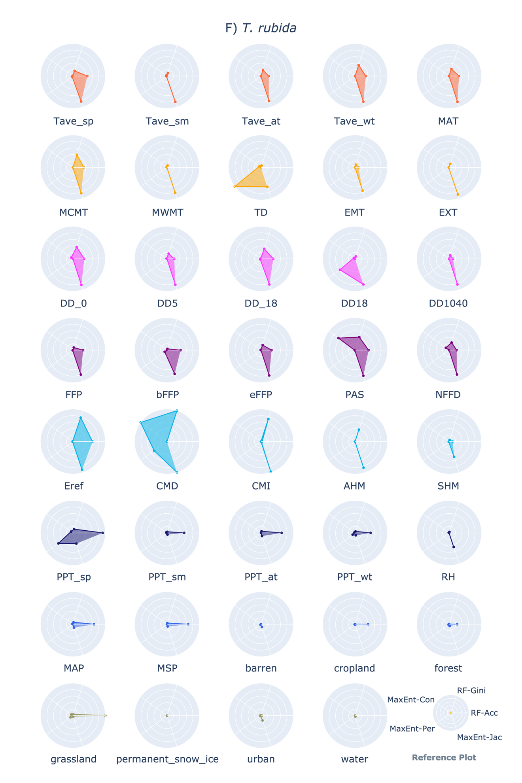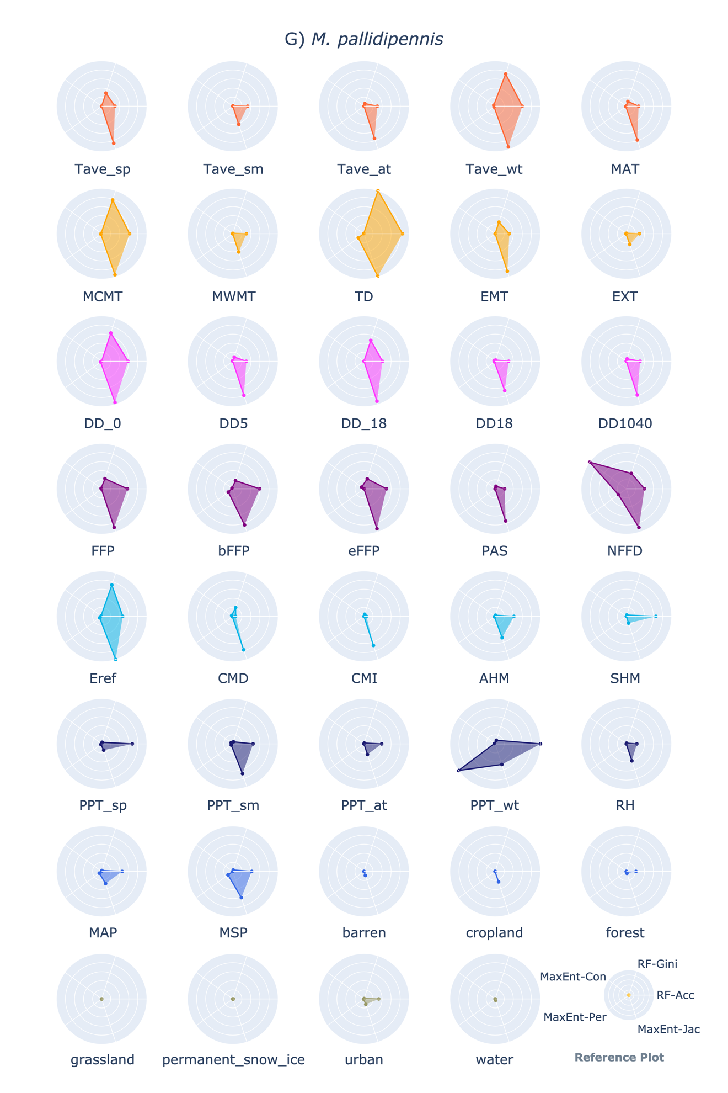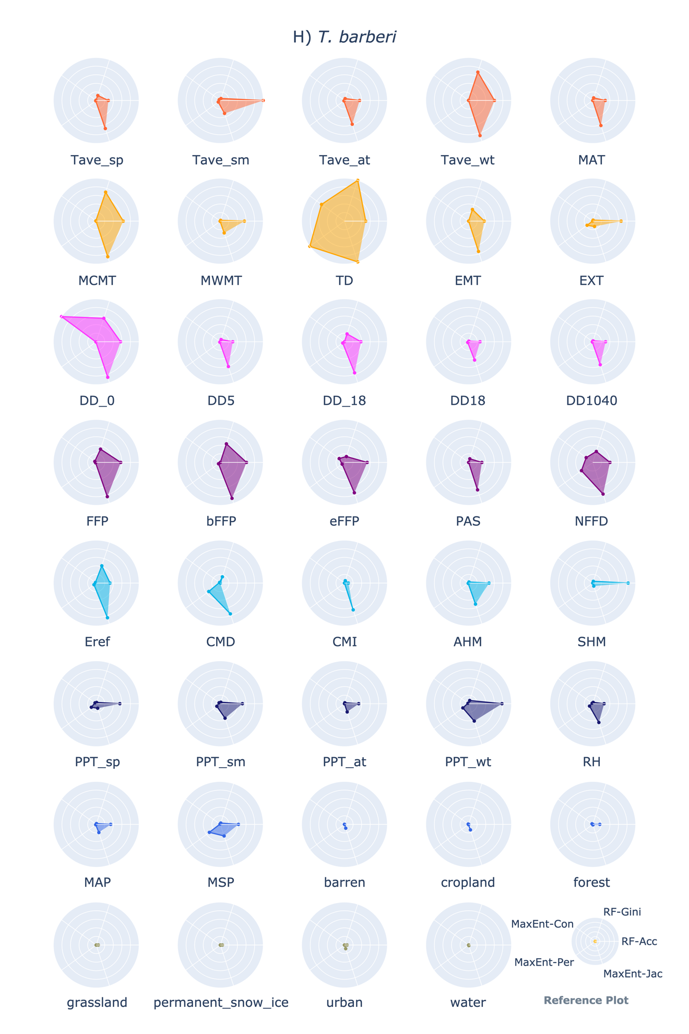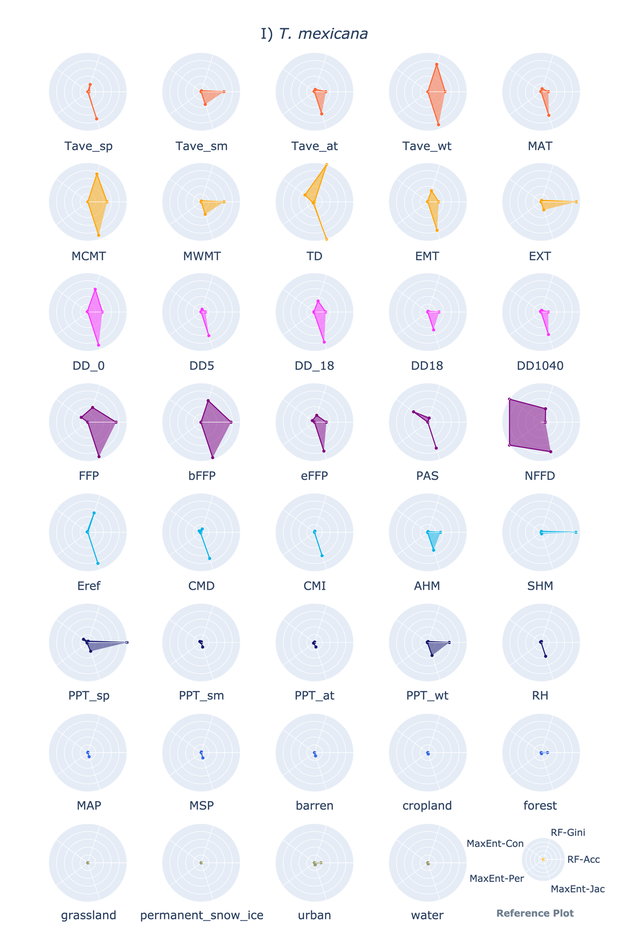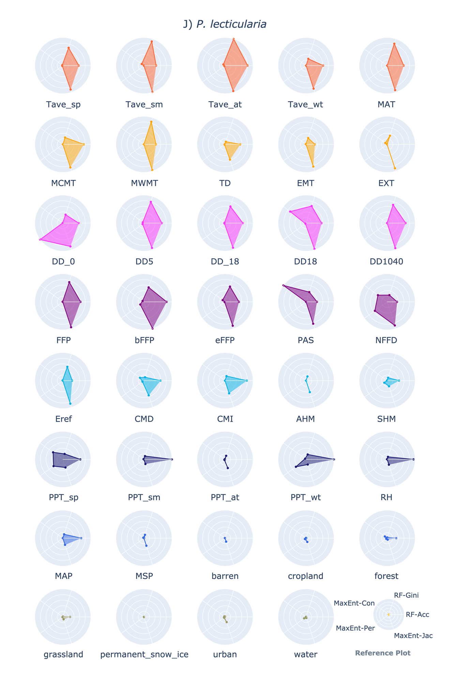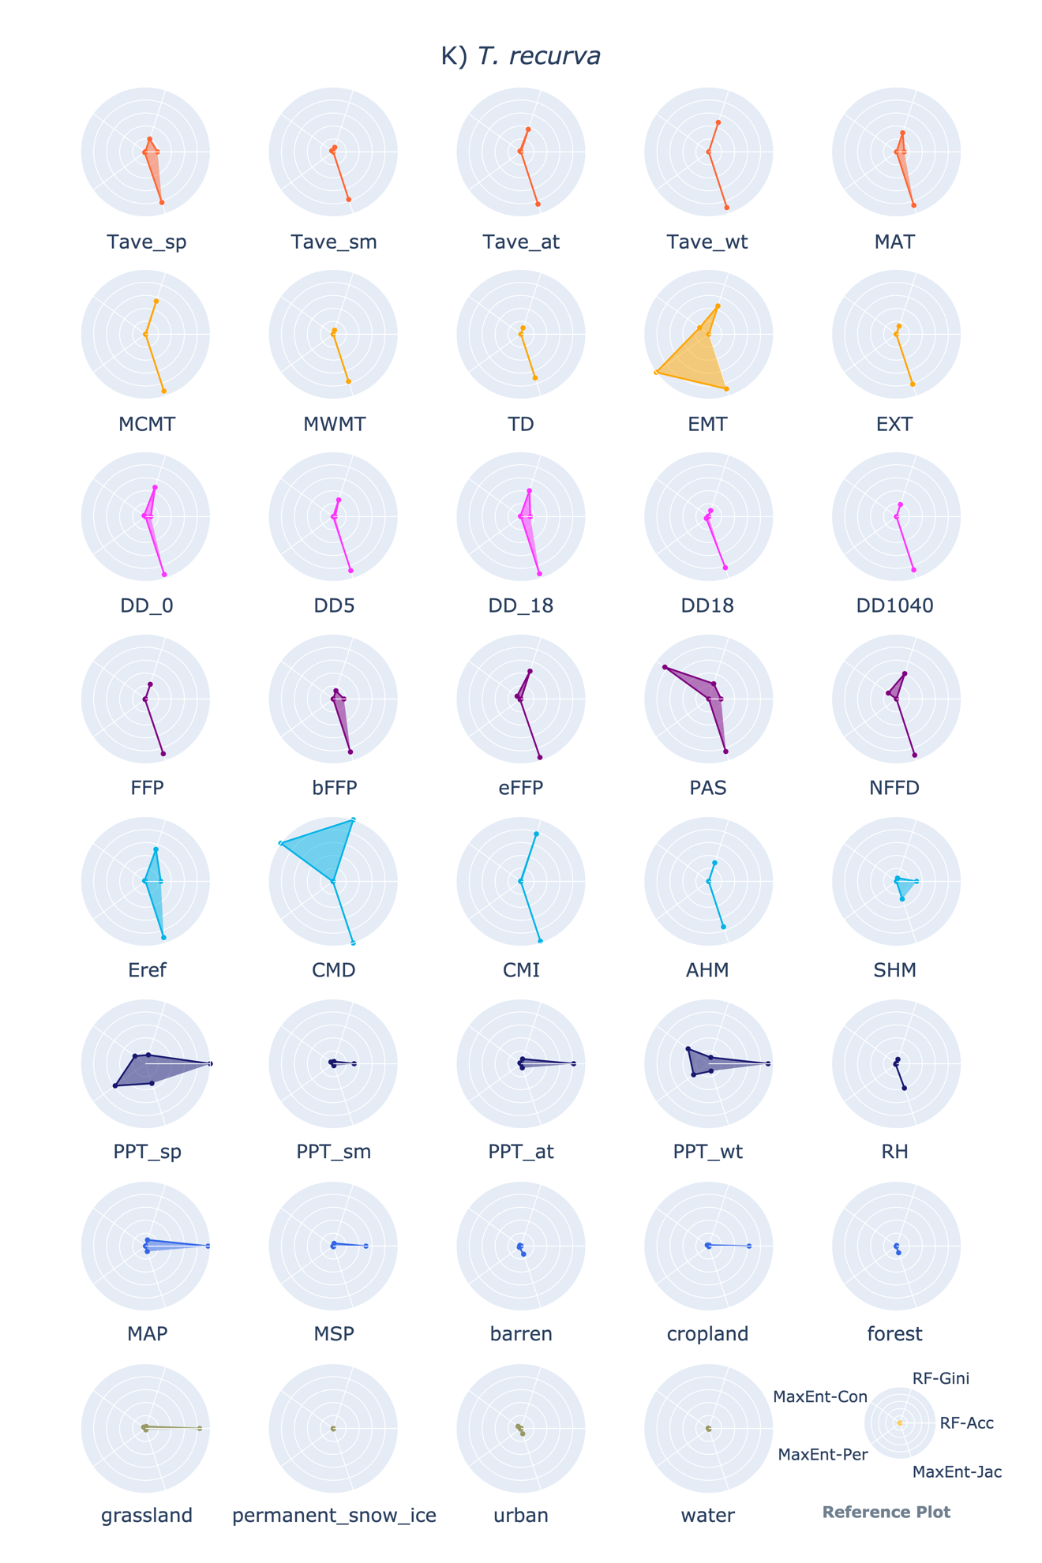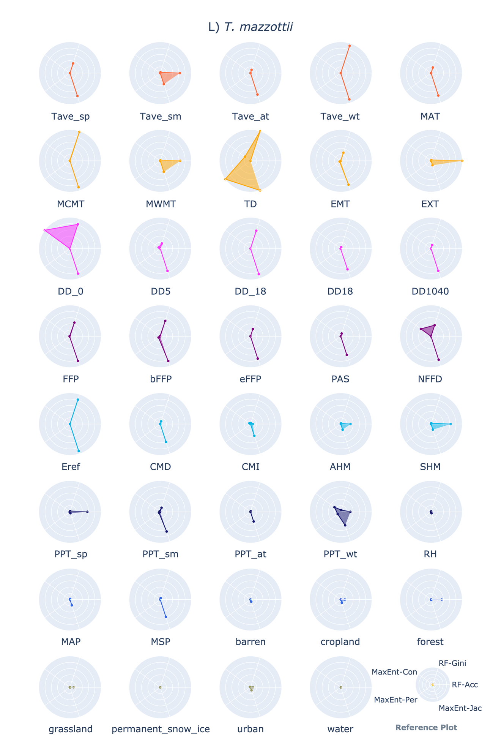

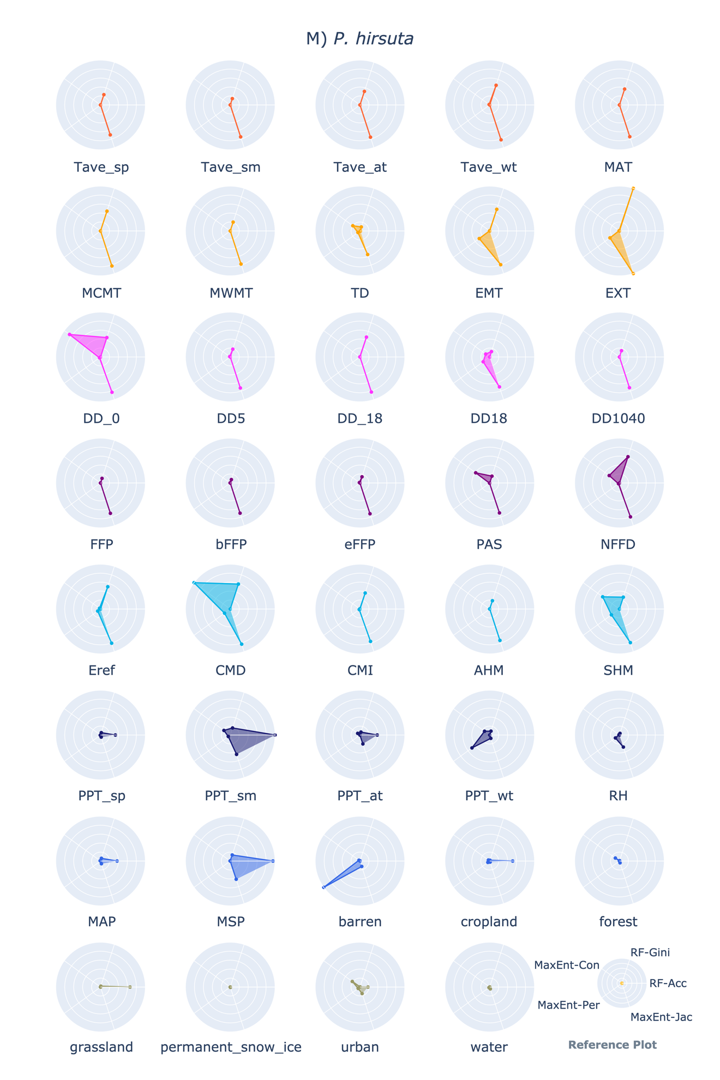

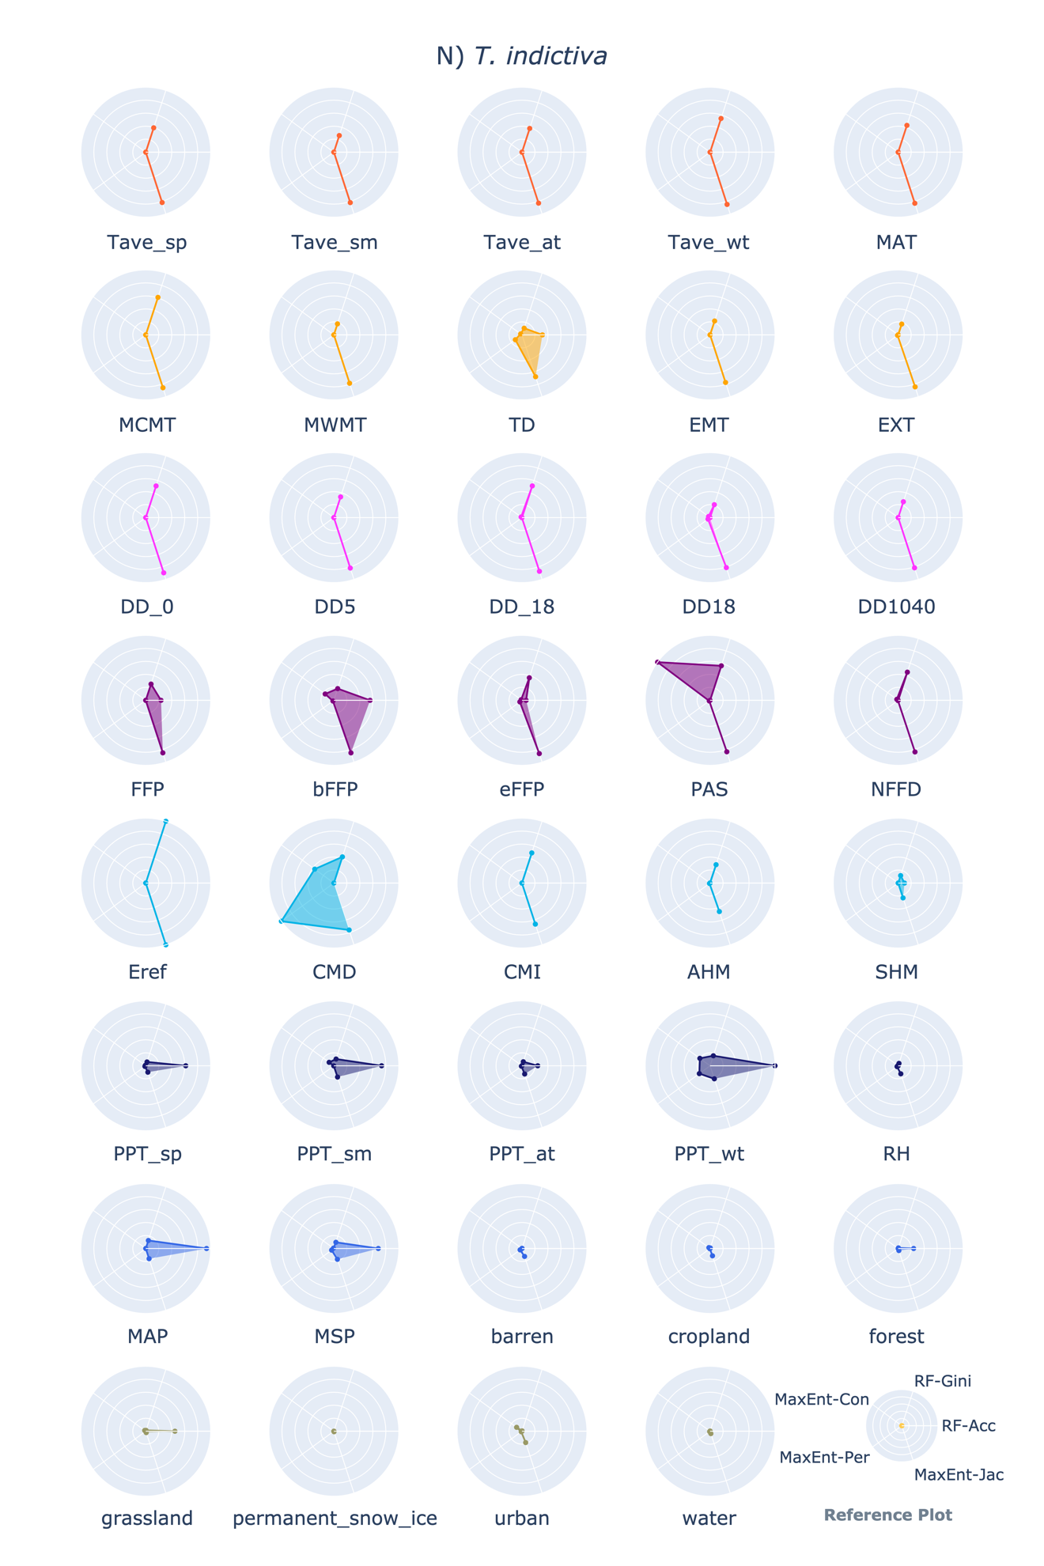

**1.4 Code**

The scripts for modeling the habitat suitability distribution and generate all these plots are shared in GitHub.

**1.5 Evidence of T. cruzi infecting 16 Triatomine species**

|  |  |
| --- | --- |
| Species | *T. cruzi* infection rate - Infection rate (sampling size) |
| *T. sanguisuga* | 55% (49) [1] |
| *T. dimidiata* | 3.7%(755) [2] |
| *T. gerstaeckeri* | 58%(1800) [3] |
| *T. protracta* | 18% (4124) [3] |
| *T. longipennis* | 18.4%(412) [4] |
| *T. rubida* | 41% (158) [5] |
| *M. pallidipennis* | 14.0% (228) [4] |
| *T. barberi* | 24.4% (157)[2] |
| *T. mexicana* | 3%(165) [6] |
| *P. lecticularia* | 51%(282) [3] |
| *T. recurva* | 13%(565) [3] |
| *T. mazzottii* | 33.9%(223) [2] |
| *P. hirsuta* | “Although it has been demonstrated to be a competent vector of T. cruzi in experimental settings, a naturally infected specimen has yet to be reported” [3] |
| *T. indictiva* | 33%(12) [3] |
| *D. maxima* | 2% (717) [7] |
| *T. phyllosoma* | 27.2% (294) [2] |

[1] Waleckx E, Suarez J, Richards B, Dorn PL. Triatoma sanguisuga blood meals and potential for Chagas disease, Louisiana, USA. Emerg Infect Dis. 2014 Dec;20(12):2141-3. doi: 10.3201/eid2012.131576. PMID: 25418456; PMCID: PMC4257814.

[2] Ramsey, Janine & Ordoñez, R & Cruz-Celis, A & Alvear, AL & Chavez, V & Lopez, R & Pintor, J & Gama, F & Carrillo, S. (2000). Distribution of domestic Triatominae and stratification of Chagas Disease transmission in Oaxaca, Mexico. Medical and veterinary entomology. 14. 19-30. 10.1046/j.1365-2915.2000.00214.x.

[3] Bern C, Kjos S, Yabsley MJ, Montgomery SP. Trypanosoma cruzi and Chagas' Disease in the United States. Clin Microbiol Rev. 2011 Oct;24(4):655-81. doi: 10.1128/CMR.00005-11. PMID: 21976603; PMCID: PMC3194829.

[4] Magallón Gastélum, Ezequiel, et al. "Distribución de los vectores de la enfermedad de Chagas (Hemiptera: Reduviidae: Triatominae), en el estado de Jalisco, México." (1998).

[5] Reisenman CE, Lawrence G, Guerenstein PG, Gregory T, Dotson E, Hildebrand JG. Infection of kissing bugs with Trypanosoma cruzi, Tucson, Arizona, USA. Emerg Infect Dis. 2010 Mar;16(3):400-5. doi: 10.3201/eid1603.090648. PMID: 20202413; PMCID: PMC3322010.

[6] Salazar Schettino PM, Rosales Piña JS, Rojas Wastavino G, Cabrera Bravo M, Vences Blanco M, López Cárdenas J. Triatoma mexicana (Hemiptera: Reduviidae) in Guanajuato, Mexico: house infestation and seasonal variation. Mem Inst Oswaldo Cruz. 2007 Nov;102(7):803-7. doi: 10.1590/s0074-02762007005000118. Epub 2007 Dec 11. PMID: 18060318.

[7] Carlos Alberto Flores-López, Lynneth Rivas-García, Guillermo Romero-Figueroa, Aldo Guevara-Carrizales, Haran Peiro-Nuño, Teresa López-Ordoñez, Rafael Bello-Bedoy, Infection Rate of Trypanosoma cruzi (Trypanosomatida: Trypanosomatidae) in Dipetalogaster maxima (Hemiptera: Reduviidae), Journal of Medical Entomology, Volume 59, Issue 1, January 2022, Pages 394–399, <https://doi.org/10.1093/jme/tjab147>